# Exemplar: Improving data model performance

# **Overview**

In the exercise *Improving Data Model Performance*, you were asked to fix a slow-loading Power BI report at Adventure Works. To complete this task, you had to identify bottlenecks in the unoptimized data model and implement changes to improve its efficiency and the overall performance of the report.

More specifically, you were asked to:

* Download the Adventure Works Power BI report titled *AdventureWorksSales.pbix* and open it in Power BI Desktop.
* Switch to Data view to observe the records contained in the report and understand the scope of data that the model is dealing with.
* Switch to Model view and change the relationship between the Customers and Orders tables from Many-to-many to One-to-many to simplify the relationship and improve performance.
* Save the changes and check to ensure that they have been implemented correctly and that the updated data model aligns with the adjustments.

This reading provides you with a guide that you can use as a benchmark for your solution. You can also refer to the videos *Resolving performance issues in the data model.*

## **Step 1: Open Your Project**

1. In Power BI Desktop, select File in the top left corner. On the File menu, select Open Report.

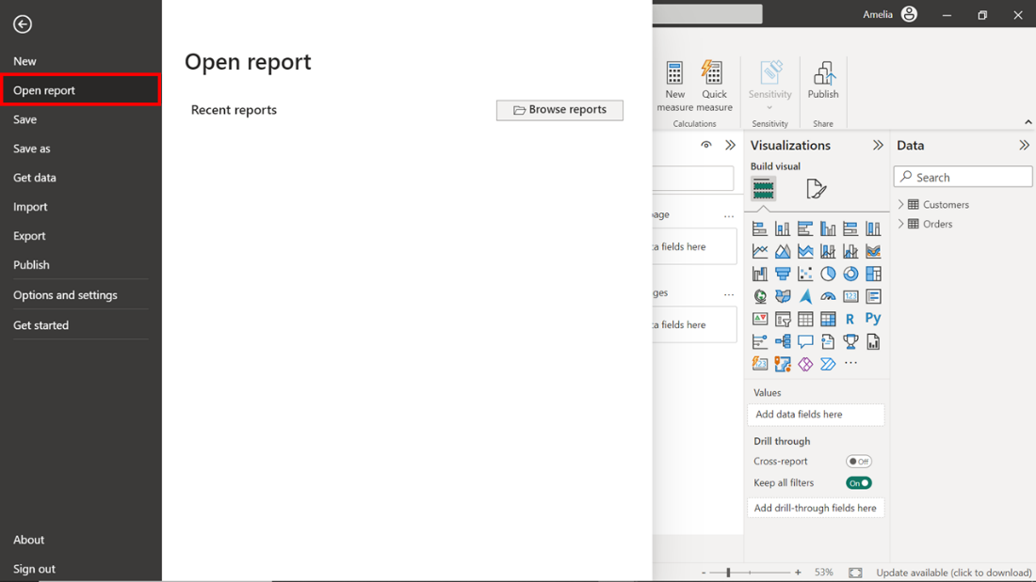

1. A dropdown menu will then appear where you select Browse Reports. Selecting this causes the file explorer window to open. Navigate to the location where you’re the downloaded file *AdventureWorksSalesReport.pbix* is saved.
2. Select the file and click Open in the File explorer window. This action opens the saved project in the Power BI Desktop application.

## **Step 2: Go to Data View**

1. In the Power BI Desktop window, you'll find a vertical toolbar with different icons on the left-hand side. The second icon from the top resembles a table and is the Data view icon. Select this icon to switch to Data view.

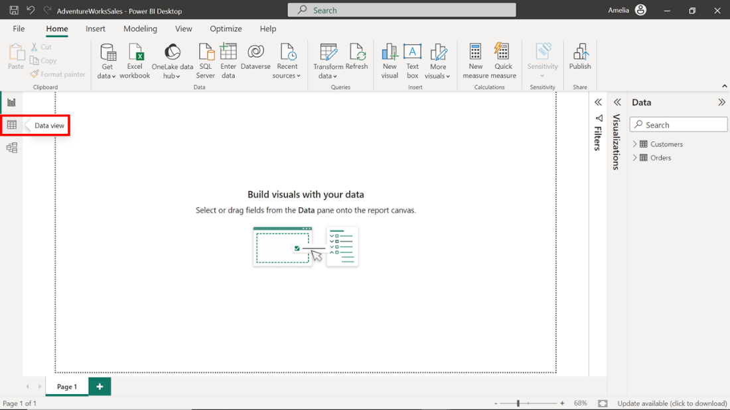

1. Power BI switches to Data view and displays the data contained in the project. Viewing this data can help you to understand the granularity and structure of the data at the most basic level. This information about the data and its structures is crucial for any kind of data analysis or data modeling. Select the Orders table on the right of the screen and take a moment to observe the first ten records. The order identified by Order ID 2003 carries the highest Order Total value of $5400 amongst the first ten records. This could result from various factors such as the quantity of goods ordered, the individual cost of each item, and the application of any taxes, fees, or discounts. It also suggests efficient transaction processing and could indicate a high-value customer.

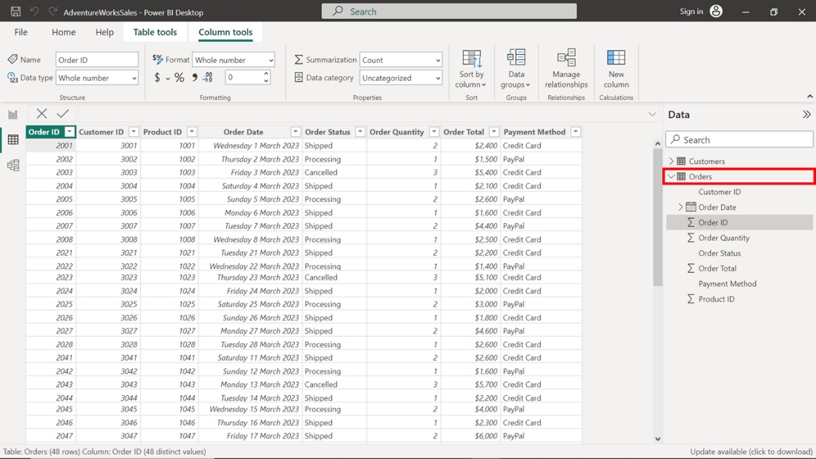

## **Step 3: Navigate to Model View**

1. The next step asks that you switch to Model view. To do this, select a different icon in the vertical toolbar on the left side of the Power BI interface. Choosing the third icon from the top switches to Model view. This icon shows three tables linked with connectors. Select this icon.

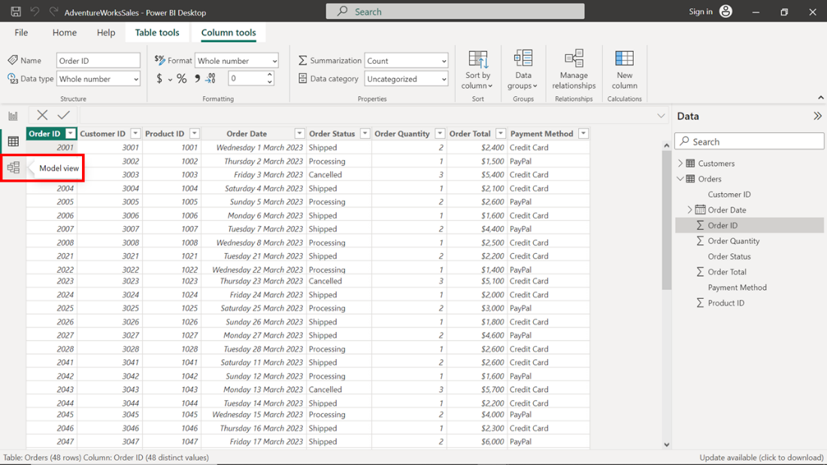

1. Model view displays a graphical representation of the tables in your report and the relationships between them. You can use this high-level overview to quickly identify and understand how different tables are interconnected. This is crucial when making modifications to improve performance.

## **Step 4: Select Relationships**

1. Model view displays a network of tables connected by lines that represent the relationships between the tables. The Customers and Orders tables line shows a many-to-many relationship (depicted by asterisks on both sides of line) that you must modify. Modification is important because it lets you configure relationships that are simpler and faster for Power BI to navigate when loading data and calculating results.

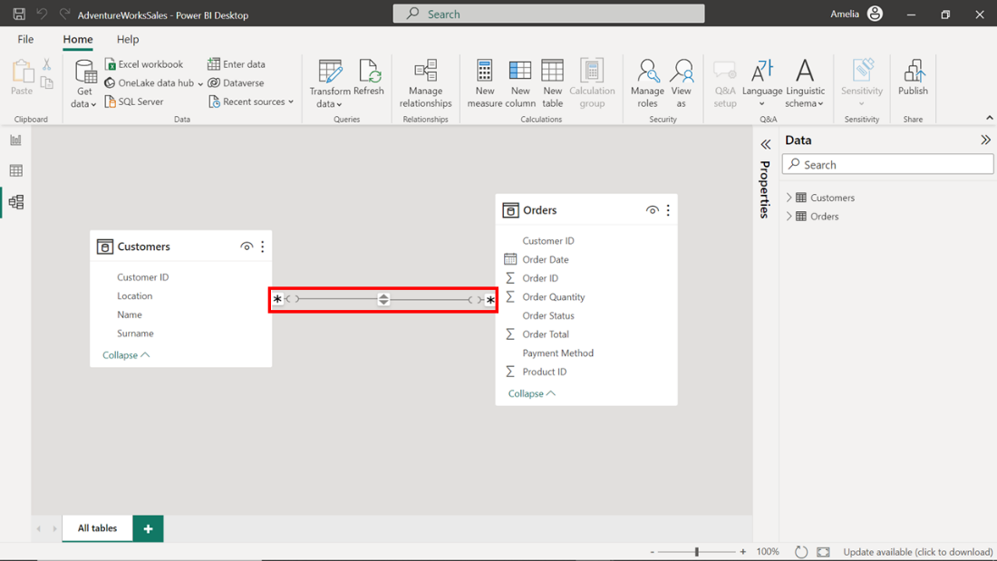

1. To modify the relationship, double-click on the line to open the Edit relationship dialog. The dialog box displays the properties of the two linked tables, Customers and Orders, and provides options to edit various aspects of the relationship, including Cross filter direction and Cardinality. To optimize the data model, you'll need to adjust both properties.
2. In the Cardinality drop-down, change the selection from its current state of Many-to-many to One-to-many. Adjusting the Cardinality from Many-to-many to One-to-many can improve performance because One-to-many relationships are simpler and faster for Power BI to navigate when loading data and calculating results.

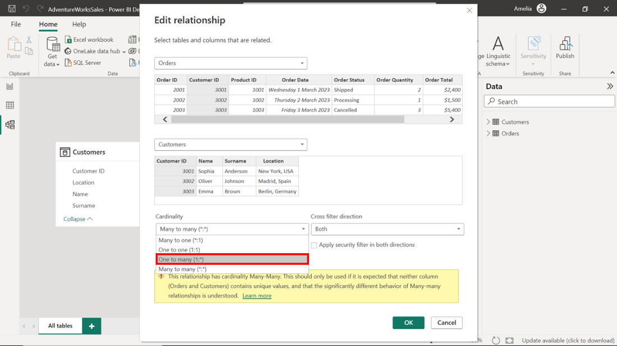

1. In the Cross-filter direction drop-down, choose the Single option to reduce the complexity of the model and limit the direction in which filters are applied. The logic behind these changes is simple: one customer can have many orders, but each order can belong to only one customer. Adjusting these settings to reflect the actual business relationships will improve the efficiency and accuracy of your data model.

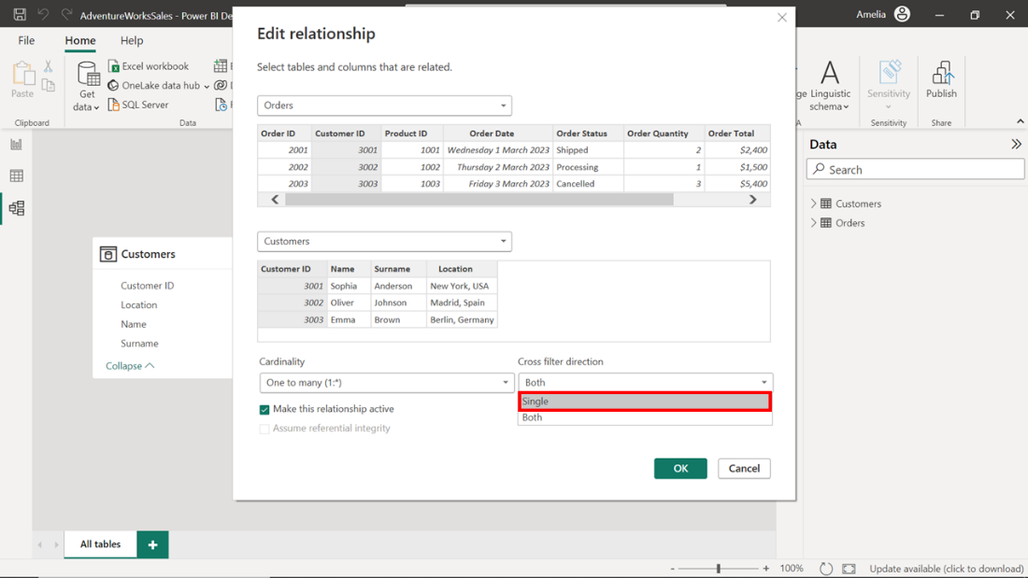

## **Step 5: Save the Changes**

1. Once you have modified the relationship properties for Customers and Orders you must save these changes for them to take effect. To save the changes made to the data model, select the OK button located at the bottom right corner of the dialog box.

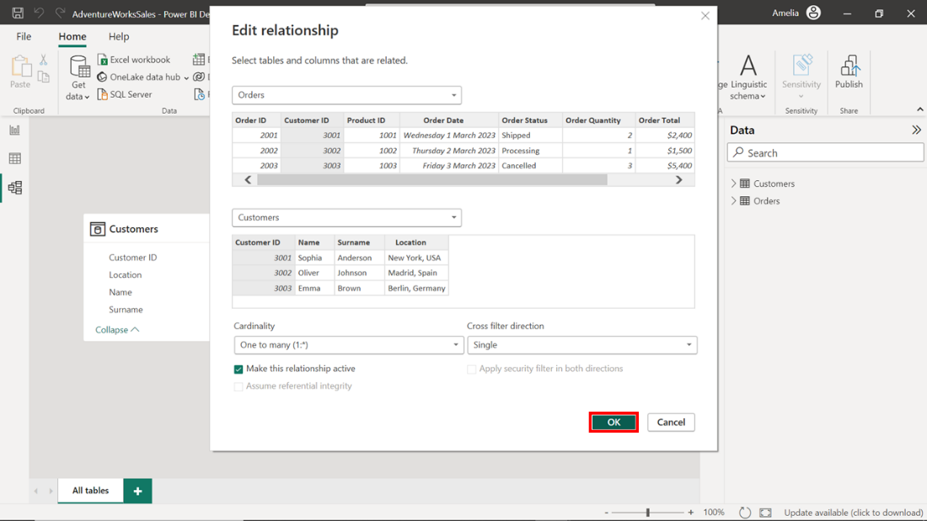

1. Once the changes are saved, review and confirm that they have been implemented by checking the relationships in the Model view. The line connecting Customers to Orders should now display the number one (1) attached to the Customers table and an asterisk (*) attached to the Orders table. This confirms that the relationship has been set to One-to-many as intended.

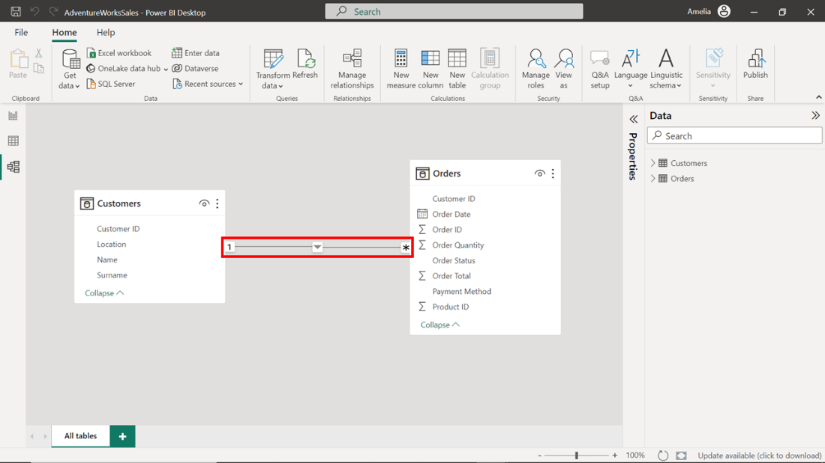

# **Conclusion**

The changes you have made to the data model in this project file will improve the quality and efficiency of the report. Streamlining the relationships in the model allows Power BI to process the data efficiently and generate visuals more quickly. This improved performance will benefit your colleagues in the Sales department who first flagged the poorly performing report. Well done!

Remember, slow-loading reports can be an opportunity, not a problem. It's an invitation to investigate, optimize, and uncover ways to make data work better.